Soybean Promotion Board 2024-2025 Report Date of Report: January 20, 2025
Title: Overcoming Soybean Yield Plateau by Leveraging Physiology-Efficient and Yield-Formation Traits
Lead Investigators: Caio Canella Vieira
Co-Investigators: Elvis Elli
Status: Year 1 of 3
Objectives: i) characterization of genetically diverse soybean accessions and modern cultivars based on yield-formation and physiology-efficient traits; ii) characterization of the genetic architecture of yield-formation and physiology-efficient traits; iii) development of breeding populations derived from high-yielding elite modern cultivars and diverse accessions.

Progress/Accomplishments: January 20, 2025 - Season Update
In 2024, two tests (24DIV_MG3 and 24DIV_MG4) with two replications each were harvested in Fayetteville and Stuttgart, Arkansas. These tests included 88 and 120 genetically diverse soybean accessions, respectively. Harvest weights and moisture levels were recorded to calculate yield. One-meter biomass samples were collected, dried, and weighed for total biomass, and threshed grain weights were subsequently recorded to calculate harvest index (HI) for all entries.

UAV imagery captured during the season was curated and shared with a third-party provider specializing in processing UAV images to generate requested image features and metrics. These will support the calculation of key traits for the study, including cumulative solar radiation interception (Ei) and radiation use efficiency (RUE). Images may also be used to train machine learning models to precisely estimate biomass and other relevant traits.

Key preliminary findings included the following:
- Stuttgart location: Mean HI was 0.42 (SD = 0.075), ranging from 0.13 to 0.66. Biomass varied from 124.2 g to 1157.5 g, and yield ranged from 1.6 to 49.9 bu/ac, with a mean of 21.78 bu/ac (SD = 8.67 bu/ac).
- Fayetteville location: Mean HI was 0.38 (SD = 0.076), ranging from 0.15 to 0.66. Biomass varied from 124.2 g to 1157.5 g, and yield ranged from 1.4 to 72.1 bu/ac, with a mean of 20.9 bu/ac (SD = 10.9 bu/ac).
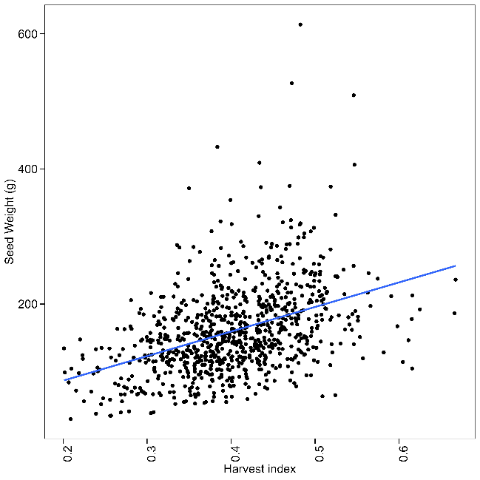
The observed variability in HI, biomass, and yield highlights significant diversity within the panel. This diversity, along with the number of entries, provides favorable conditions for identifying genetic loci associated with the traits under study. Interestingly, although seed weight and harvest index are correlated, it appears that these two traits are somewhat independent and may be targeted individually to improve overall yield potential (Figure 1). Genetic studies will be crucial in confirming these statements.
Figure 1. Relationship of harvest index and seed weight. Although correlated, traits appear to be independent, highlighting the potential of targeting them independently to improve grain yield.

Upcoming Actions/Activities:
- Complete processing of UAV images.
- Generate response values for calculating Ei and RUE.
- Calculate Ei and RUE based on canopy solar radiation interception and utilization.
- Conduct a preliminary genome-wide association study (GWAS) for Ei, RUE, and HI using 2024 data.
- Design and package entries for 2025 trials, which will be established as replicated randomized complete block design trials.

